CAR-T for Lymphoma: Discharge Summary Template.

CAR-T Specific Events
Indication for CAR-T:

Prior Disease Narrative:

Background:

Bridging therapy:

Disease status at Infusion:

Lymphodepletion
Flu/Cy
Other:

Product infused:
Axicel (Yescarta)
Brexucel (Tecartus)
Tisagen (Kymriah)

Date of Infusion & Cell Dose:

Toxicity:
CRS
Max grade (ASTCT) -
Date of onset -
Therapy: Tocilizumab Corticosteroids

Neurotoxicity (ICANS)
Max grade (ASTCT) -
Date of onset -
Therapy: Dexamethasone, Other (e.g. high dose methylprednisolone, anakinra, siltuximab)
Symptoms (delete as appropriate):
Altered writing
Altered mental status (e.g. reduced ICE score)
Aphasia
Focal motor deficit (e.g. hemiparesis)
Seizures
Tremor
Visual hallucinations
Cerebral oedema
Other:

ICAHT (Immune Effector Cell-Associated Heamatotoxicity):
Max Grade:
Treatment: e.g. transfusion/growth factor
During admission:
On Discharge:

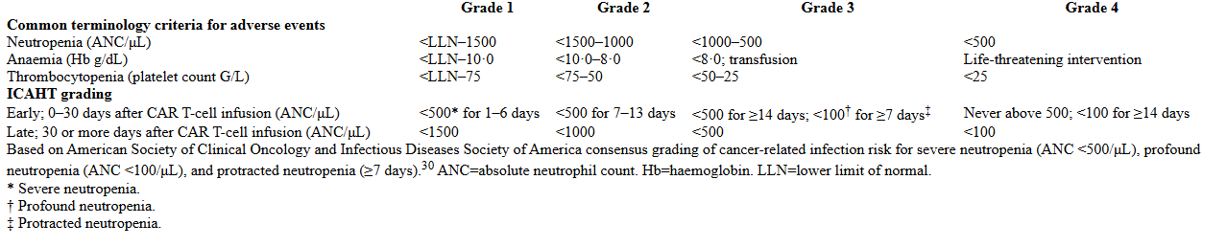

Other organ toxicity
e.g. skin, liver etc…
Onset date:
Grade as per CTCAE:

Infection during infusion period?
Please document isolates and date of cultures, antibiotic therapy and resolution of infection:

Summary of inpatient stay:

Ambulatory care and follow-up plan:

Transfusion/growth factor plan on discharge:

Infection prophylaxis on discharge:

Levetiracetam weaning plan on discharge:

Steroid weaning plan on discharge (if appropriate):

Copy to:
Notes
Referring hospital consultant, if indicated

